**09–Dictionary**

**Ex.No. : 9.1 Date:**

**RegisterNo.: 231501070 Name: Kaaleeswaran v**

## Uncommonwords

Asentenceisastringofsingle-spaceseparatedwordswhereeachwordconsistsonlyoflowercaseletters.Awordisuncommonifitappearsexactlyonceinoneofthesentences,anddoesnotappearintheothersentence.

Given two sentences s1 ands2, return a list ofall the uncommon words. You mayreturntheanswerinanyorder.

Example1:

Input: s1 = "this apple is sweet", s2 = "this apple is sour"Output:["sweet","sour"]

Example2:

Input:s1="appleapple",s2="banana"Output:["banana"]

Constraints:

1<=s1.length,s2.length <=200

s1ands2consistoflowercaseEnglishlettersandspaces.s1ands2donothaveleadingortrailingspaces.

Allthewordsins1ands2areseparatedbyasinglespace.Note:

Usedictionarytosolvetheproblem

**Forexample:**

|  |  |
| --- | --- |
| **Input** | **Result** |
| thisappleissweetthisappleis sour | sweetsour |

# Program:

a=input().split()b=input().split()c1,c2,l={},{},[]

foriina:c1[i]=c1.get(i,0)+1

forjinb:c2[j]=c2.get(j,0)+1

forw,cinc1.items():if(c==1andwnotinb):

l.append(w)

forw,cinc2.items():if(c==1andwnotina):

l.append(w)print(*l)

# Output:

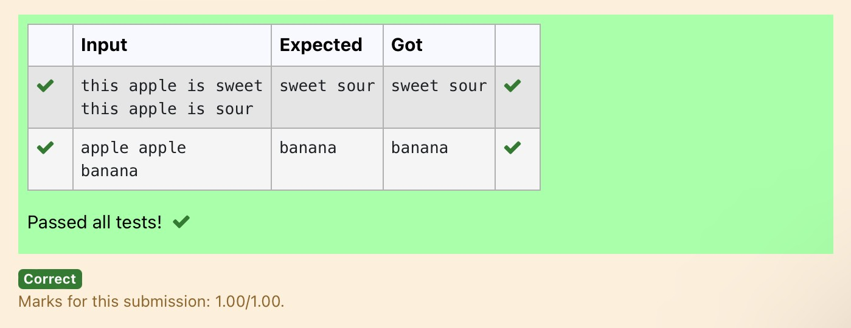

**Ex.No. : 9.2 Date:**

**RegisterNo.: Name:**

## Sort DictionarybyValuesSummation

Giveadictionary with valuelists,sort thekeys bysummationofvaluesin valuelist.

**Input**:test_dict={‘Gfg’:[6,7,4],‘best’ :[7,6,5]}

**Output**:{‘Gfg’:17,‘best’:18}

**Explanation** : Sorted by sum, and replaced.**Input** : test_dict = {‘Gfg’ : [8,8], ‘best’ : [5,5]}**Output**:{‘best’:10,‘Gfg’:16}

**Explanation** : Sorted by sum, and replaced.SampleInput:

2

Gfg674

Best765SampleOutputGfg17

Best18

**Forexample:**

|  |  |
| --- | --- |
| **Input** | **Result** |
| 2  Gfg674  Best765 | Gfg17  Best18 |

# Program:

**a=int(input())d={}**

**foriinrange(a):b=input()b=b.partition("")d[b[0]]=b[-1].split("")**

**n=list(d.values())k=list(d.keys())**

**foriinrange(len(n)):s=0**

**forjinrange(len(n[i])):**

**s+=int(n[i][j])**

**d.update({k[i]:s})l=list(d.items())if(l[0][1]<l[1][1]):**

**fork,vind.items():print(k,v)**

**else:**

**j=1**

**fork,vind.items():if(j==1):**

**k1,v1=k,vj+=1**

**else:**

**print(k,v)print(k1,v1)**

# Output:

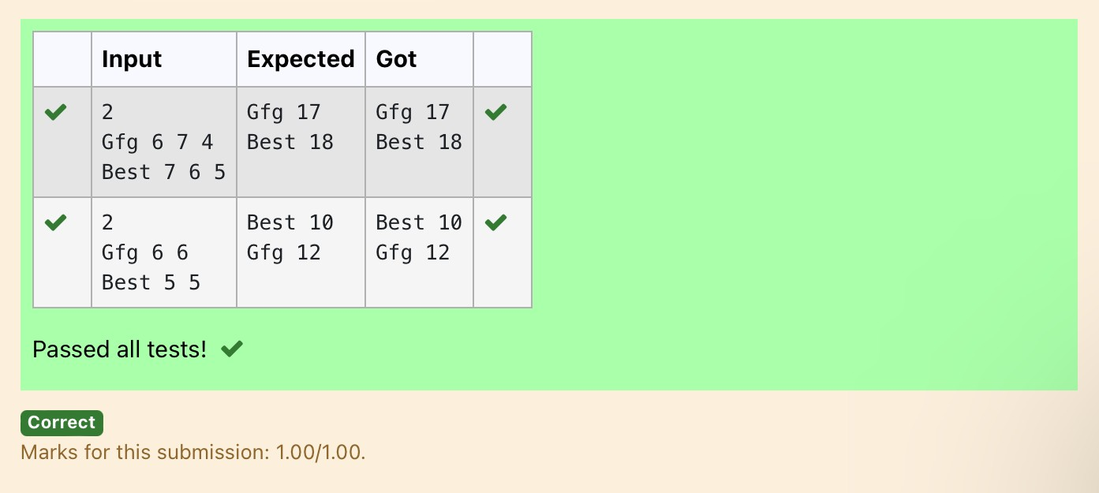

**Ex.No. : 9.3 Date:**

**RegisterNo.: Name:**

## WinnerofElection

Given an array of names of candidates in an election. A candidate name in the arrayrepresents a vote cast to the candidate. Print the name of candidates received Maxvote.Ifthereistie,printalexicographicallysmallername.

**Examples:**

Input:votes[]={"john","johnny","jackie","johnny","john","jackie",

"jamie","jamie","john",

"johnny","jamie","johnny","john"};

Output:John

WehavefourCandidateswithnameas'John','Johnny','jamie','jackie'.The candidates John and Johny get maximum votes. Since John is alphabetically smaller,weprintit.Usedictionarytosolvetheaboveproblem

**SampleInput:**

10

JohnJohnJohnyJamieJamieJohnyJackJohnyJohnyJackie

**SampleOutput:**

Johny

**Forexample:**

|  |  |
| --- | --- |
| **Input** | **Result** |
| 10  JohnJohnJohnyJamieJamieJohnyJack | Johny |

|  |  |
| --- | --- |
| **Input** | **Result** |
| JohnyJohnyJackie |  |

# Program:

n=int(input())

votes={}

for_inrange(n):candidate=input()

votes[candidate]=votes.get(candidate,0)+1

max_votes=max(votes.values())

max_candidates=[candidateforcandidate,countinvotes.items()ifcount==max_votes]

print(min(max_candidates))

# Output:

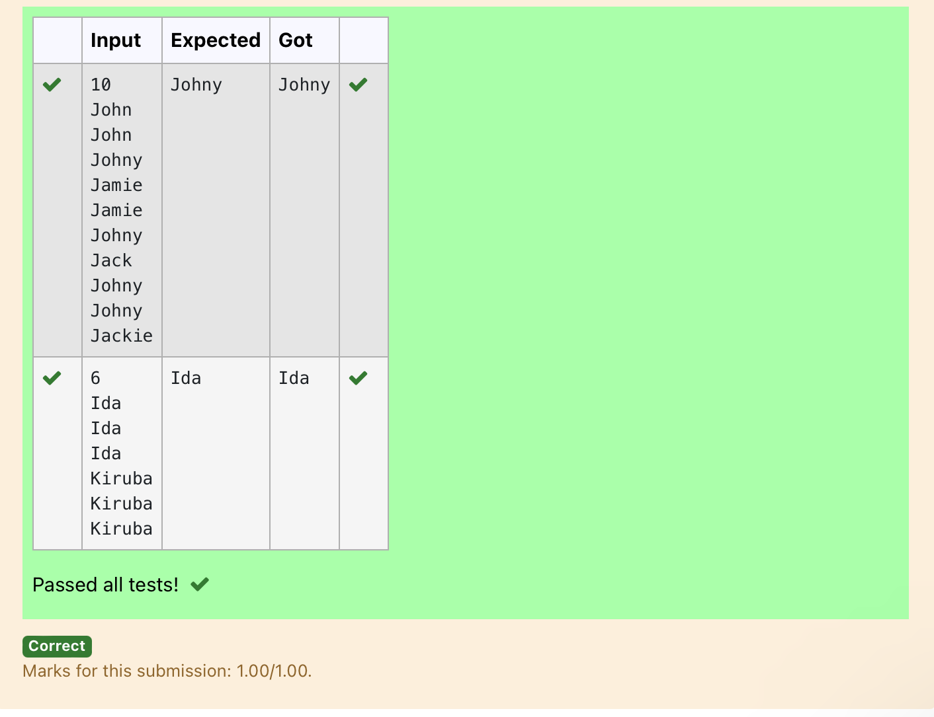

**Ex.No. : 9.4 Date:**

**RegisterNo.: Name:**

## StudentRecord

Create a student dictionaryfor n students with the student name as key andtheir testmarkassignmentmarkand labmarkasvalues.Dothefollowingcomputationsanddisplaytheresult.

1.Identifythestudent withthehighest[average](https://www.rajalakshmicolleges.net/moodle/mod/quiz/view.php?id=5717)score2.Identify the student who as the highest Assignment marks3.IdentifythestudentwiththeLowestlabmarks

4.Identifythestudentwiththelowest[average](https://www.rajalakshmicolleges.net/moodle/mod/quiz/view.php?id=5717)scoreNote:

Ifmorethanonestudenthasthesamescoredisplayallthestudentnames

Sampleinput:

4

James678956

Lalith894545

Ram898989

Sita707070SampleOutput:

Ram

James RamLalithLalith

# Program:

n=int(input())max_average=float('-inf')min_average=float('inf')

max_assignment = float('-inf')min_lab=float('inf')max_average_students=[]max_assignment_students=[]min_lab_students=[]min_average_students=[]

for_inrange(n):

name,test,assignment,lab=input().split()test=int(test)

assignment=int(assignment)lab=int(lab)

average=(test+assignment+lab)/3ifaverage>max_average:

max_average=averagemax_average_students=[name]

elifaverage==max_average:max_average_students.append(name)

ifaverage<min_average:min_average=averagemin_average_students=[name]

elifaverage==min_average:min_average_students.append(name)

ifassignment>max_assignment:max_assignment=assignmentmax_assignment_students=[name]

elifassignment==max_assignment:max_assignment_students.append(name)

iflab<min_lab:min_lab=lab

min_lab_students = [name]eliflab==min_lab:

min_lab_students.append(name)print(*sorted(max_average_students))print(*sorted(max_assignment_students))print(*sorted(min_lab_students))print(*sorted(min_average_students))

# Output:

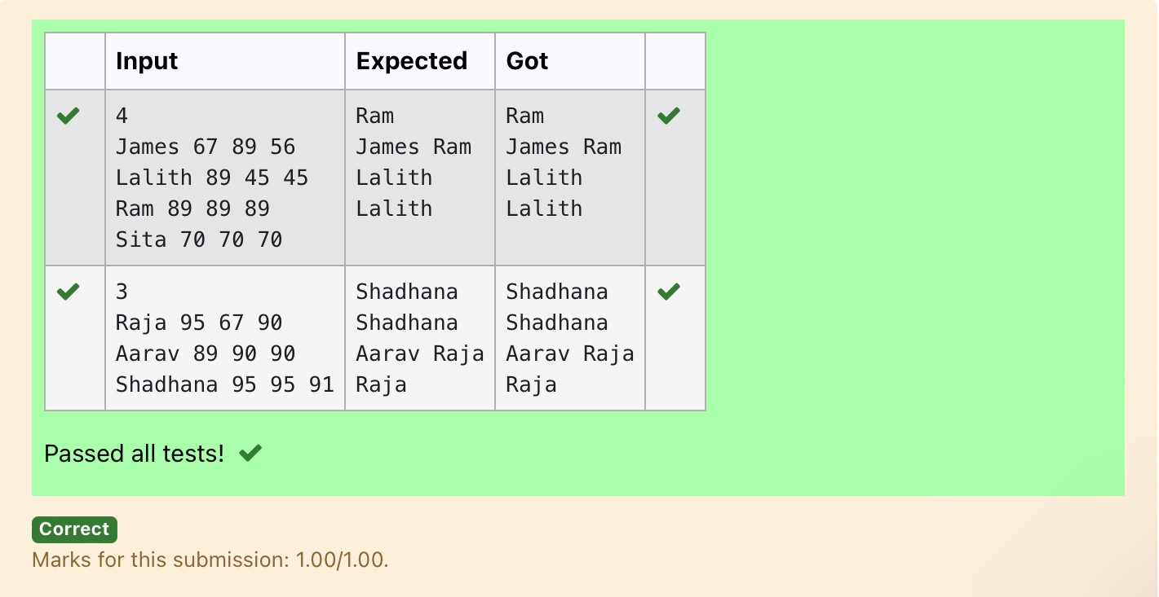

|  |  |  |
| --- | --- | --- |
| **Ex.No. :** | **9.5** | **Date:** |
| **RegisterNo.:** |  | **Name:**  **[ScrambleScore](https://www.rajalakshmicolleges.net/moodle/mod/quiz/view.php?id=5780)** |

In the game of Scrabble™, each letter has points associated with it. The total score ofa wordis thesum ofthescores of its letters. More common letters are worthfewerpointswhile lesscommonlettersareworthmorepoints.

Write a program that computes and displays the Scrabble™ score for a word. Createadictionarythatmaps from letters to point values. Then use the dictionarytocomputethescore.

A Scrabble™ board includes some squares that multiply the value of a letter or thevalueofanentireword.Wewillignorethesesquaresinthisexercise.

Thepointsassociatedwitheachletterareshownbelow:PointsLetters

1. A,E,I,L,N,O,R,S,TandU
2. DandG
3. B,C,MandP
4. F,H,V,WandY
5. K

8 J and X10QandZ

[Sample](https://www.rajalakshmicolleges.net/moodle/mod/quiz/view.php?id=5127)InputREC

[Sample](https://www.rajalakshmicolleges.net/moodle/mod/quiz/view.php?id=5127)Output

RECisworth5points.

# Program:

letter_scores={

'A': 1,'E':1,'I':1,'L':1, 'N': 1,'O':1,'R':1,'S':1,'T':1,'U':1,

'D':2,'G':2,

'B':3,'C':3,'M':3,'P':3,

'F':4,'H':4,'V':4,'W':4,'Y':4,

'K':5,

'J':8,'X':8,

'Q':10,'Z':10

}

word=input().upper()

score=sum(letter_scores.get(letter,0)forletterinword)print(word,"isworth",score,"points.")

# Output:

